**EXPERIMENT NO. 8**

**Designing a two network configuration and updating the routing table of a**

**router for a given topology (Static Routing)**

**Aim**

To design a two network configuration and updating the routing table of a router for a given topology (Static Routing).

**Objectives**

1. Studying and implementing static routing.
2. Connecting two different networks, configuring the interfaces and updating routing table of given router for the given topology.

**Procedure**

**Design following network scenarios:**

**Scenario 1: Network with 1 Router**

1. Start packet tracer and design the network as given in Figure 1.
2. Configure the router and end devices as described in section below.
3. Test the configuration either by using a ping command or by sending simple PDUs.

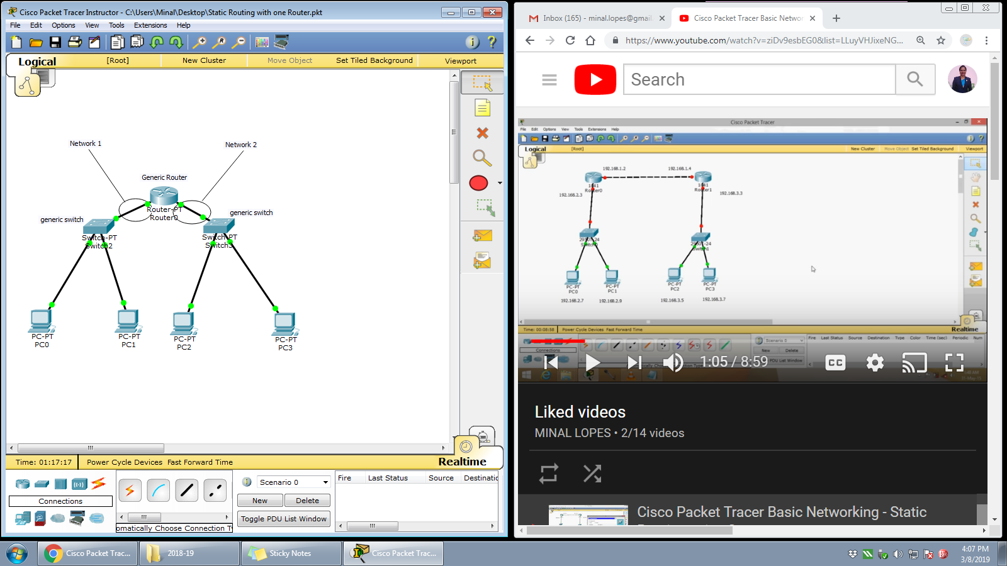

Figure 1

**Router Configuration:**

1. Reboot Router 0 by powering OFF and ON under the physical tab.
2. Router performs the Power ON Self-Test (POST).
3. Click on ‘Config’ tab and then choose one of the interface for configuration. Provide appropriate IP address and subnet mask.
4. Proceed similarly for all other interfaces in use.
5. To update the routing table of ‘Router 0’ follow these steps,
   1. Identify magnifying glass icon available at the vertical right pane of the packet tracer. Click the magnifying glass on to Router 0 and select the routing table from the drop down list. A routing table for Router 0 will be displayed having 2 entries typed as C (connected) with next hop field blank.
   2. The routing table is to be updated with the next hop entry, so that the Simple PDU could be send on to the other network. Provide following entries in the routing table: Network Address, Subnet mask, Next Hop.
6. Configure all the end devices by providing them IP address, subnet mask and the default gateway address.
7. Test your network by sending simple PDU’s or pinging the computers from one network to other network.
8. Specify your network’s configuration details in table given below.

| **Sr. No.** | **Network Device** | **Configuration (IP address, subnet mask, default gateway addr)** |
| --- | --- | --- |
| 1 | Generic Router 0 | Interface: FastEthernet 0/0  IP address: 192.168.1.1  Subnet address:255.255.255.0 |
| Interface: FastEthernet 1/0  IP address:192.168.2.1  Subnet address:255.255.255.0 |
| 2 | PC0 | IP Address:192.168.1.2  Subnet address:255.255.255.0  default gateway:192.168.1.1 |
| 3 | PC1 | IP Address:192.168.1.3  Subnet address:255.255.255.0  default gateway:192.168.1.1 |
| 4 | PC2 | IP Address:192.168.2.2  Subnet address:255.255.255.0  default gateway:192.168.2.1 |
| 5 | PC3 | IP Address:192.168.2.3  Subnet address:255.255.255.0  default gateway:192.168.2.1 |

**Scenario 2: Network with 2 Router**

1. Start packet tracer and design the network as given in Figure 2.
2. Configure the router and end devices as described.
3. Test the configuration either by using a ping command or by sending simple PDUs.

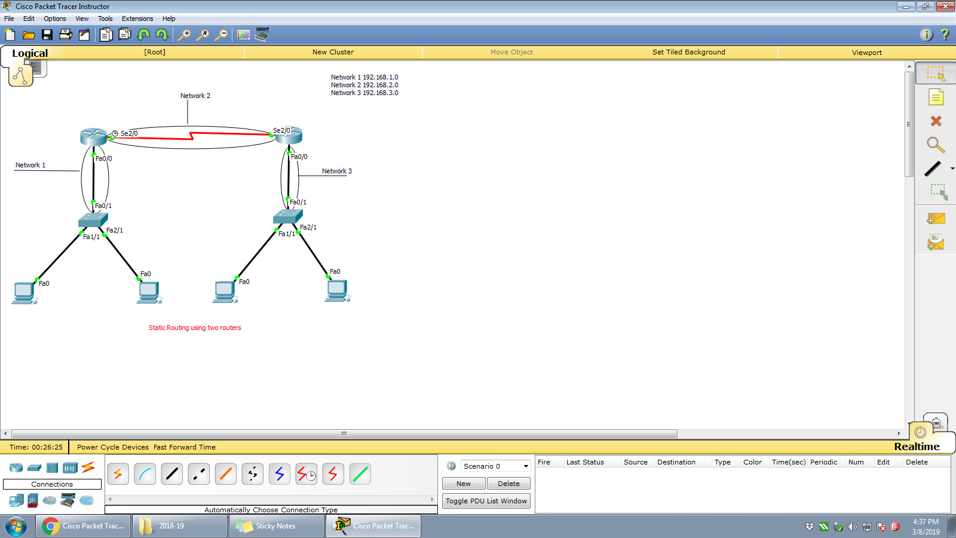

Figure 2

| **Sr. No.** | **Network Device** | **Configuration (IP address, subnet mask, default gateway addr)** |
| --- | --- | --- |
| 1 | Generic Router 0 | Interface: FastEthernet 0/0  IP address:192.168.1.1  Subnet address:255.255.255.0 |
| Interface: Serial 2/0  IP address:192.168.2.1  Subnet address:255.255.255.0 |
| Static Routing Table  192.168.3.0/24 via 192.168.2.2 |
| 2 | Generic Router 1 | Interface:FastEthernet 0/0  IP address:192.168.3.1  Subnet address:255.255.255.0 |
| Interface: Serial 2/0  IP address:192.168.2.2  Subnet address:255.255.255.0 |
| Static Routing Table  192.168.1.0/24 via 192.168.2.1 |

Take screenshots for both the network scenarios showing successful PDU transmission from one network to other and attach as the output.

**Conclusion:**

In this experiment the routers interfaces and routing tables are configured statically and checked that simple PDU’s are transmitted from one network to another through routers. Thus we learned to design a simple network with routers using static routing.

**Post Experiment Exercise:**

Design a network with three routers to perform static routing. Draw the diagram (on journal sheet) and indicate all the configurations required to perform static routing.

*#SCENARIO 1:NETWORK WITH 1 ROUTER*  ***RIYA INDAP,44***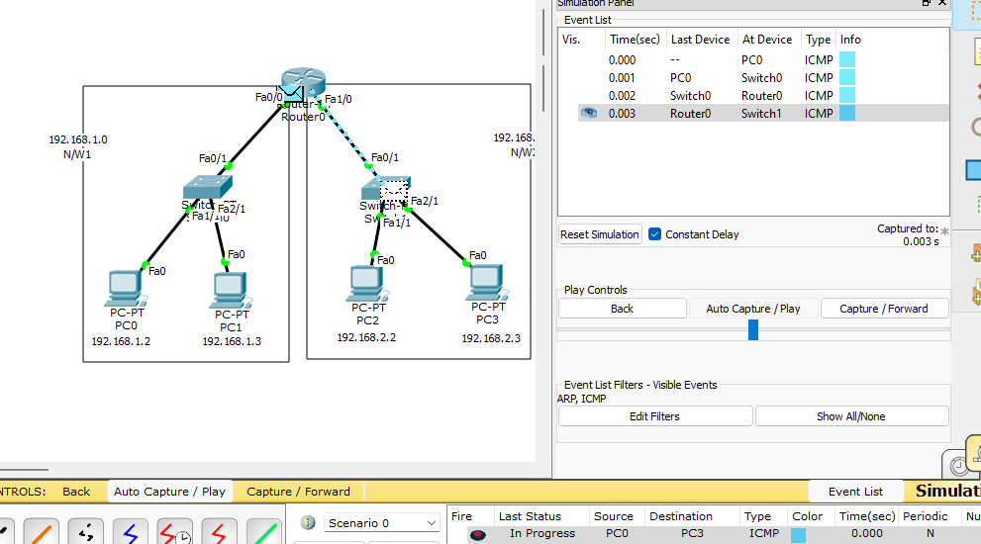

* *Two understand how packets are transferred from one network to another network we constructed a network with two individual networks connected to a single router.We configured the individual networks and for the router common to both network we configured its two interfaces Fa0/0 and Fa1/0 with the gateway addresses of individual networks.*

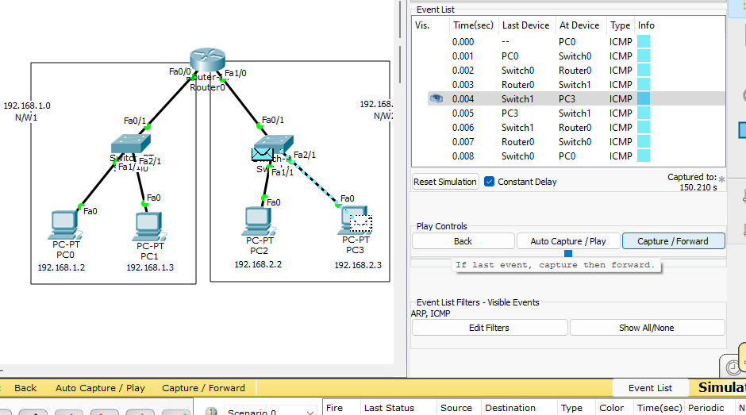

*When a packet arrives at the router0 from a device PC0 on one network,the router examines the destination IP address of the packet.The router consults its routing table to determine the best path to forward the packet towards its destination network.*

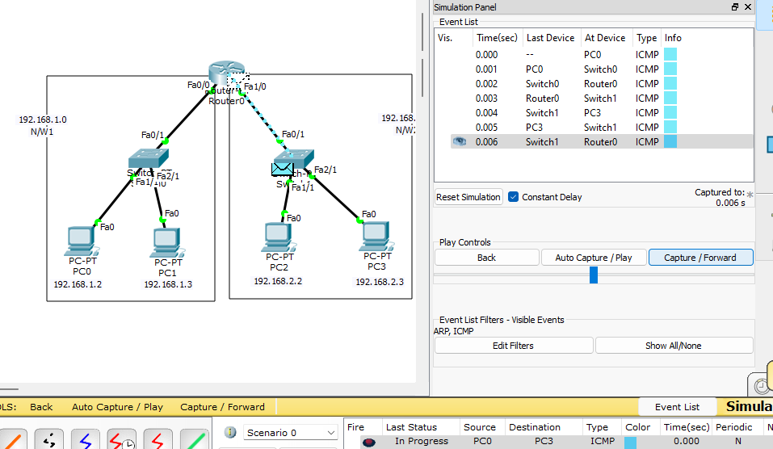

*The packet is delivered to the intended recipient device ,PC3 on the destination network.The recipient device receives the packet and processes the data contained within it.If necessary the recipient device may generate a response.*

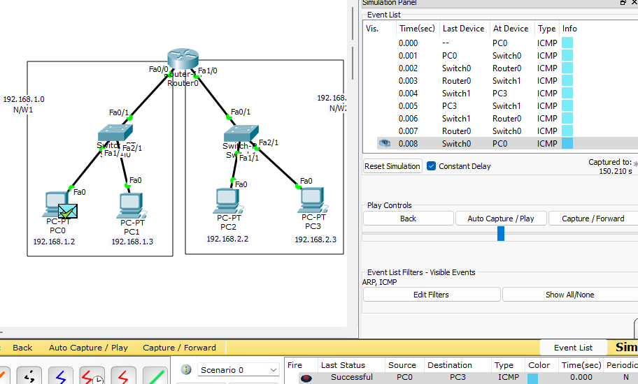

*The generated response hence follows a similar process of routing and transmission back to source device PC0 .Thus, the PDU is gives a successful output on stimulation panel.*

*#SCENARIO 2:NETWORK WITH TWO ROUTERS* 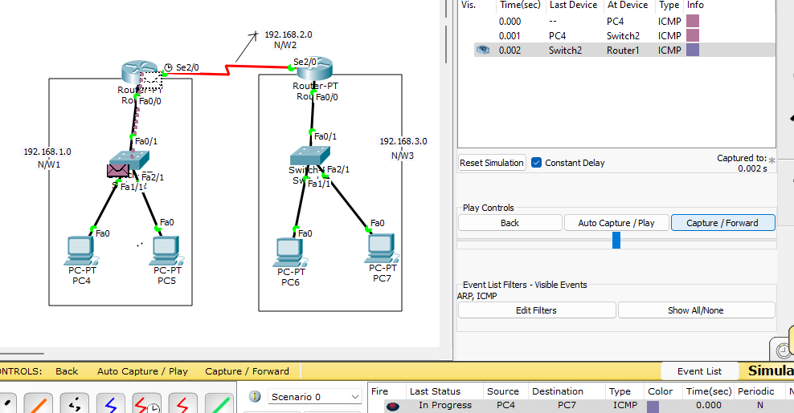

* *To understand how packets are transferred from one network to another which are connected to their individual routers and those routers and connected to each other,we built a network ith this description and configured it and sent packets from pc4 to pc7.The source device sends a packet to its default gateway which is a router1 interface connected to same network.*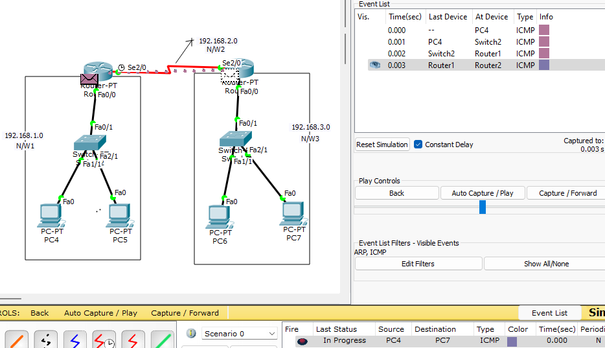
* *The router1 examines the destination IP address of the packet and consults its routing table to determine the next hop for the packet.Based on the routing table entries,the router selects the next-hop router,ie. router2 to forward the packet toward the destination network.*

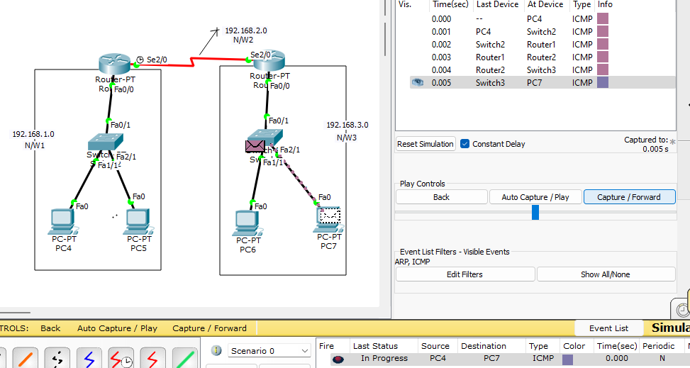

* *The next hop router2 receives the packet on one of its interfaces.It de-encapsulates the packet,examines the destination Ip address,.As the packet has reached the router that has directly connected interface to the destination network.This router forwards the packet onto the destination device,PC7.The recipient device receives the packet and processes the data contained within it.If necessary the recipient device may generate a response.*

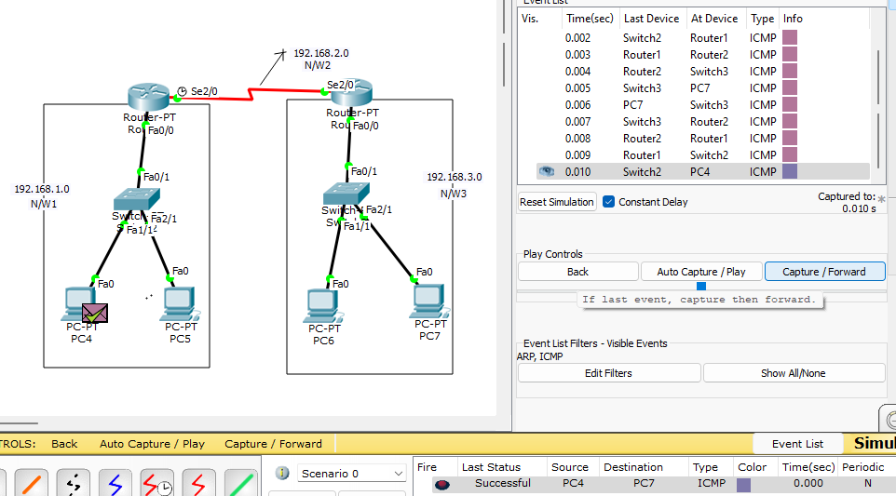

* *The generated response hence follows a similar process of routing and transmission back to source device PC4.Thus, the PDU is gives a successful output on stimulation panel.*